Step 1: Go to the following website to watch a video on how a dividing starfish reproduces HERE.

Where is Associate Professor Mike Barker studying dividing starfish?

How do these starfish reproduce?

Step 2: Go to the following website HERE to explore various organisms and decide if they reproduce sexually or asexually.

ASEXUAL REPRODUCTION - produces offspring that are ...
to a single parent.

SEXUAL REPRODUCTION - Two parents contribute genetic information to produce...

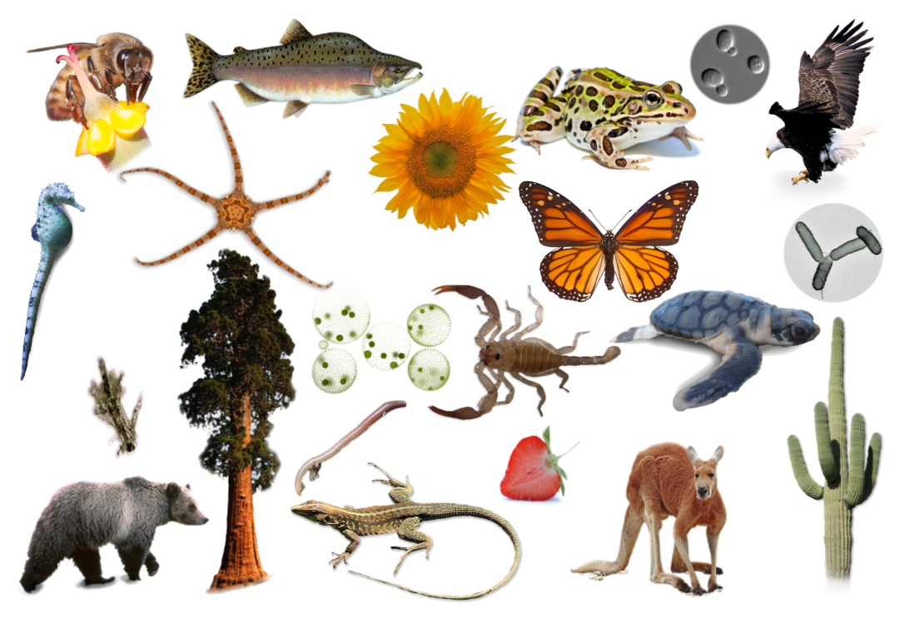

Step 3: Fill in the table below by using the website. When you click on the organism, information will pop up. Notice that you will need to check BOTH boxes on some organisms.
Organism | Reproduces Sexually | Reproduces Asexually
Honey Bee
Sea Horse
Giant Amoeba
Grizzly Bear
Pink Salmon
Brittle Star
Coast Redwood
Sunflower
Volvox
Earthworm
Whiptail Lizard
Leopard Frog
Monarch Butterfly
Sand Scorpion
Garden Strawberry
Baker’s Yeast
Flatback Sea Turtle
Red Kangaroo
Bald Eagle
Salmonella
Saguaro Cactus

Step 4: From the table above, try to make some general observations about the organisms that reproduce sexually versus asexually.

In general, which organisms tend to be more complex, those that reproduce sexually or asexually?

In general, which organisms have more diversity within their species, those that reproduce sexually or asexually?

Step 5: While on vacation, you discover a new (fictional) organism. Read through the description below.
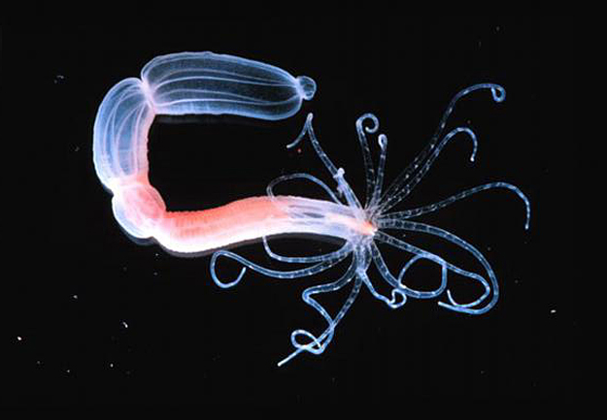
new organism was discovered in the ocean off the coast of California. The first colony of 500 organisms was found all clustered together huddled close to some coral. After further study, similar colonies were located up and down the pacific coast at the similar depths. All of the organisms seem to be of similar size and shape. There are no genders among the organisms. To produce offspring they seem to use a form of budding, where the offspring grow off the parent.

Give a new name to your newly discovered organism.

Decide if the organism is reproducing sexually or asexually.

A disease comes through the colony of your organism. Is it likely that the entire colony will survive? Why or why not?

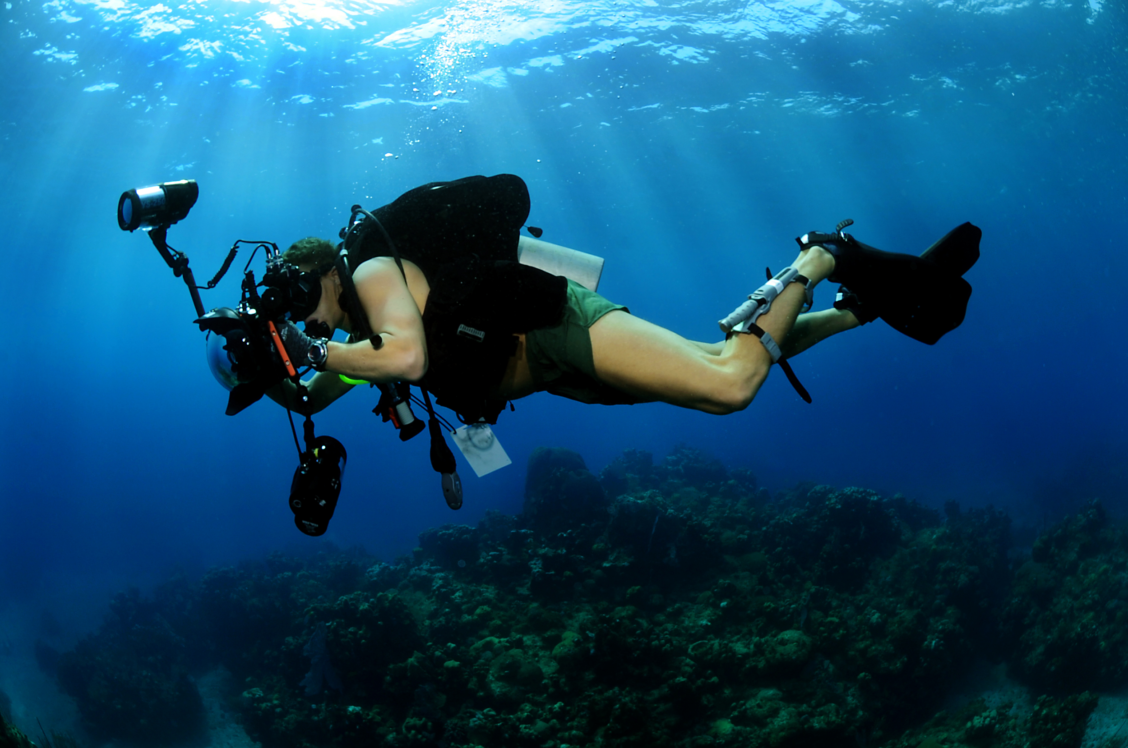

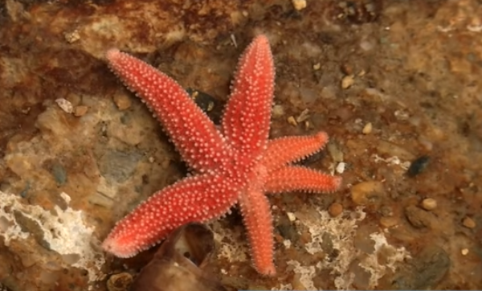
Reproductive Strategies of Organisms
Name: Answer Key

Step 1: Go to the following website to watch a video on how a dividing starfish reproduces HERE.

Where is Associate Professor Mike Barker studying dividing starfish?
New Zealand coast

How do these starfish reproduce?
Divide in half and then grow the other side

Step 2: Go to the following website HERE to explore various organisms and decide if they reproduce sexually or asexually.

ASEXUAL REPRODUCTION - produces offspring that are ...
Genetically identical
to a single parent.

SEXUAL REPRODUCTION - Two parents contribute genetic information to produce...
Unique offspring

Step 3: Fill in the table below by using the website. When you click on the organism, information will pop up. Notice that you will need to check BOTH boxes on some organisms.
Organism | Reproduces Sexually | Reproduces Asexually
Honey Bee
Sea Horse
Giant Amoeba
Grizzly Bear
Pink Salmon
Brittle Star
Coast Redwood
Sunflower
Volvox
Earthworm
Whiptail Lizard
Leopard Frog
Monarch Butterfly
Sand Scorpion
Garden Strawberry
Baker’s Yeast
Flatback Sea Turtle
Red Kangaroo
Bald Eagle
Salmonella
Saguaro Cactus

Step 4: From the table above, try to make some general observations about the organisms that reproduce sexually versus asexually.

In general, which organisms tend to be more complex, those that reproduce sexually or asexually?
Sexually reproducing organisms

In general, which organisms have more diversity within their species, those that reproduce sexually or asexually?
Sexually reproducing organisms

Step 5: While on vacation, you discover a new (fictional) organism. Read through the description below.

A new organism was discovered in the ocean off the coast of California. The first colony of 500 organisms was found all clustered together huddled close to some coral. After further study, similar colonies were located up and down the pacific coast at the similar depths. All of the organisms seem to be of similar size and shape. There are no genders among the organisms. To produce offspring they seem to use a form of budding, where the offspring grow off the parent.

Give a new name to your newly discovered organism.
Answers will vary

Decide if the organism is reproducing sexually or asexually.
Asexually

A disease comes through the colony of your organism. Is it likely that the entire colony will survive? Why or why not?
No, there is little to no genetic diversity so the chances of survival are smaller than with more genetic diversity.

If you would like to open this using google docs, go to the following link:
https://docs.google.com/document/d/16IpIUD_GzZtyqMMZgLV3Zv6TLnvdPMLscZHCCIwM2Oc/copy

Follow the prompts by Google to make your own copy
Repeat this process for the answer key:
https://docs.google.com/document/d/1NlPCjzgqzuUkVZC92674S377uH2BU6V-CpVeuQEd13g/copy

